Welcome!
Date
Name
Spouse
Address
City
State Zip _________
Email

Please Contact By
Card Phone Visit

Telephone Best Time to Call
Home ______________
Work ______________

Guest: First Time Second Time
Are you a church member: yes no
Church
City, State

Circle Appropriate Age/Grade Group(s)
Preschool: Ages: B-1 2-3 4-5
Children: Grades: K 1 2 3 4 5 6
Youth: Grades: 7 8 9 10 11 12
Adults: Ages:18-29 30s 40s 50s 60s+

How did you learn about our church?
Newspaper Friend Yellow Pages Mail
Other

I am a guest of:

New in the Community? Yes No
Names & ages of children at home

Weekly Service & Activity Schedule

September 7, 2014
9:45 a.m. Sunday School
11:00 a.m. Morning Worship Service
12 noon Kids In Action
6:00 p.m. Evening Worship

Week of September 7
Wednesday, 7:00 p.m. Youth Activities
Wednesday, 7:00 p.m. Adult Prayer & Bible Study
Thursday, 10:00 a.m. Adult Fellowship

Upcoming Events
September
1-30…………………….........……. Mary Hill Davis Offering
14…………………………………………….Business Meeting
24…………………………………………..See You at the Pole
25……………………………………….…….Adult Fellowship
Birthday & Anniversary Recognitions will occur on the final Sunday of each month.
YOUR CHURCH NEEDS YOU!!

The Nominating Committee is working to fill positions for the new year beginning Sept. 1st. Nominating Committee members: Ray Edwards Chair, Angie Fisher, Otisann McManus, Teresa Schane, Sheila Waggoner, Timothy Williams and Cleyon Davis. If you have not been contacted and wish to serve in some capacity, please let us know. Interest Forms are in the foyer. We welcome your help!

Knobbs Springs Baptist Church

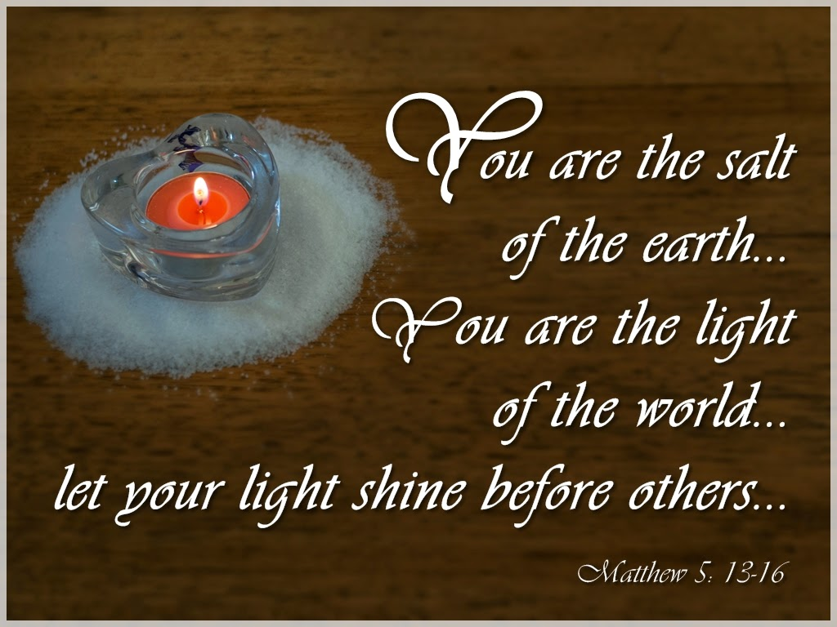

Welcome Bro. James Roberts

September 7, 2014

Church Information:

KnobbsSpringsBC.com KnobbsSpringsBaptist@gmail.com
1662 CR 305, McDade, Texas 78650 512-273-2743
Patti Radford, Office Manager 512-968-7821

